 | Orange Township Public Schools  Mr. Patrick Yearwood Jr.  Principal | 

Gerald Fitzhugh, II, Ed.D.

Superintendent of Schools

Noel Cruz, Dean of Students Aimie Smith, Assistant Principal Christina Tighe, Ed.D. Assistant Principal

August 18, 2022

Dear Parents, Guardians, and Caregivers,
We are excited for the start of the 2022-2023 school year at Lincoln Avenue School! We are partners jointly dedicated to helping your child grow socially, emotionally, and intellectually. Please be reminded that students report for the first day of school on Wednesday, September 7, 2022. This school year will be filled with continued opportunities to cultivate your child’s educational practice. I am confident we will have a successful, productive, enriching school year for all our stakeholders involved in the Lincoln Avenue community.

We have a new Assistant Principal Mrs. Aimie Smith who has joined our team. I know that she is excited to meet you and your scholars. She will work alongside the staff and me in order to move Lincoln Avenue School from Good to Great! We also have Dr. Christina Tighe returning in our Assistant Principal position and Mr. Noel Cruz as our Dean of Students. I look forward to this seeing everyone. It is going to be a great year!

MORNING ROUTINE FOR STUDENTS
Students are to be dropped off at the following locations:
- Kindergarten, 1st grade, 2nd grade, and 3rd grade – Students are dropped off and proceed through the cafeteria entrance where staff will meet them.
- 4th grade, 5th grade, 6th grade, and 7th grade – Students enter through the double glass doors near the gymnasium and report directly to the gymnasium where staff will meet them.
- Breakfast will continue to be held in the classroom this year.
- Students must arrive to school by 8:30 a.m. Attendance is vital to instruction. We need our students on time and present each day.
DISMISSAL
- All students are dismissed at 3:00 p.m.
- Please arrive promptly at that time to pick up your child.
- In the event you are unable to pick up your child on a certain day, please provide prompt, written notification to the main office. Please include the name of the person who will serve in your capacity.
- Kindergarten will be dismissed from their classroom doors.
- 1st grade, 2nd grade, and 3rd grade students are dismissed through the cafeteria courtyard located on Frankfort Street.
- 4th grade and 5th grade students are dismissed on the playground next to our parking lot.
- 6th grade and 7th grade students are dismissed through the doors leading to our field by the cafeteria located on Frankfort Street.
STUDENT ATTIRE
Students should dress according to the uniform policy. Sneakers must always be worn for physical education classes. Uniforms must be worn daily. The following are the expectations for the dress code:

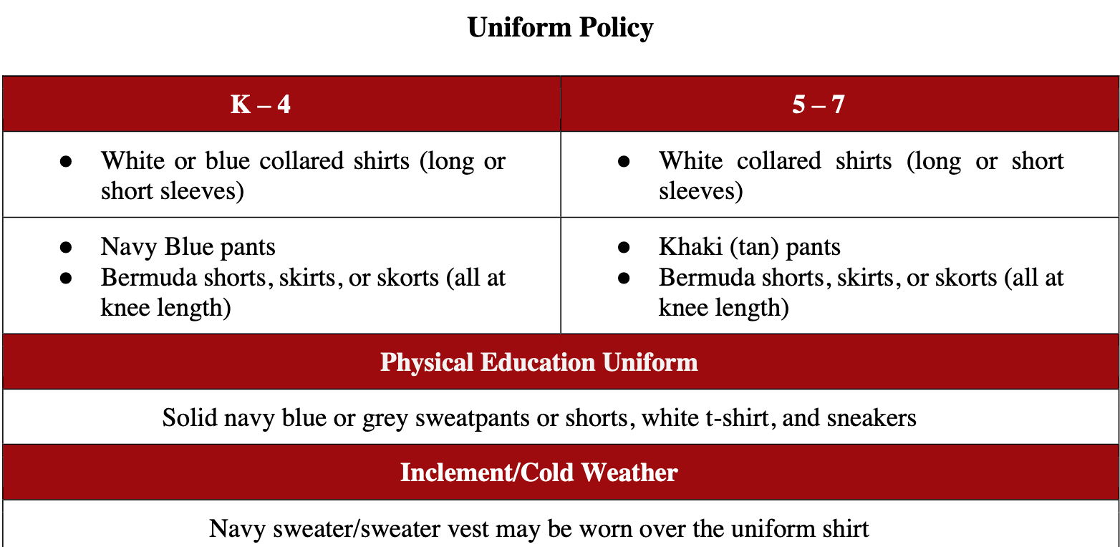

The following items of clothing are not permitted as part of the school dress code:
• Blouses or sweaters that show a bare midriff, crop tops, halter tops, bandanas, tank tops, tops with spaghetti or thin straps, short shorts, short mini-skirts, clinging or form fitting spandex leggings (leggings are permitted only under an appropriate length skorts, shorts, skirt, or dress), pants/jeans worn below the waist, and pants/jeans that are ripped.). All flannel-type pants and sleepwear are not permitted. All hats are not permitted.
• Please be sure that appropriate and safe footwear is worn at all times. Specifically, no flip-flops, clogs, crocs or “sliders” are not to be worn due to the safety factor when using stairs. All sandals must be secured at the toes and ankle for safety.
CLASSROOM SUPPLIES: For information regarding classroom supplies, please visit our school website.
STUDENT ABSENCES
Parents are responsible for reporting daily absences to Lincoln Avenue School secretaries, at 973-677-4130.

FORMS
Students will receive the emergency contact form on the first day of school. Please review and complete the emergency form and other corresponding forms by September 14, 2022. It is important that these forms are returned to have active communication with you throughout SY 22-23.
AFTER SCHOOL PROGRAM:
• Afterschool clubs will be held on Fridays, beginning October through May from 3:10PM – 4:10PM for students in grades 2 – 7. The following are tentative clubs for the upcoming school year:
Robotics Team | Geography Bee | Girls Who Code | Instrumental Club
Student Government | Vocal Club (Choir) | Wellness Club | Cheerleading
Dance Club | Art Club | Debate Club | Game 24 Club
• Afterschool enrichment programs (offered only in Mathematics and English Language Arts) will be held on
Tuesdays, Wednesdays, and Thursday, beginning in October through May from 3:10PM – 4:10PM for
students in grades 1 – 7. Dates for clubs will be sent under separate cover in the beginning of September.
CHROMEBOOKS
Students are expected to bring their district issued Chromebook to school each day. The Chromebook should be fully charged.
COMMUNICATION
• All teachers and staff will be connected to our students and families using “Class Dojo.” Please ensure you have connected with your child’s classroom teacher on this platform and check the “school story” daily for any
announcements.
• E-mail & phone blasts will also be used to communicate with families. Please ensure you have updated your contact information in Genesis. It is imperative that all school personnel have the most updated information for your household.
• Being able to communicate with our parents is extremely important. Please ensure that all your information is
updated.
• All your student’s important information will be accessed through the Parent Portal. This will include his/her progress reports, grades, missing assignments, and other concerns that may impact your child’s performance or well-being. If you have not done so, please ensure that you sign up for Parent Portal.
• Please listen to the phone blasts sent by the school and/or District. They include important information and guidance.
• If you have not signed up for the Orange App, you can download it on your Android or Apple iPhone.
• The School District & Lincoln Avenue’s social media platforms are a great source for receiving updates & important information as well as celebrating and sharing photos of our fun activities.

You can also follow our school on the following social media platforms:

Twitter:
▪ Orange Public School District
▪ Lincoln Ave Panthers (@LincolnAve216)
Instagram:
▪ Orange Public School District
▪ LASPanthers
Facebook: Orange Public School District

Kindergarten Parents

Enclosed you will find a colored bracelet for your child to wear the first day back to school that matches the color of their teacher. Please make sure that they have it on so we can easily identify your child and what class they are in.
Looking forward to a happy, healthy, and productive school year!
Educationally yours,

Patrick Yearwood Jr.

Patrick Yearwood Jr.,
Principal

